**PHINMA UPANG COLLEGE OF INFORMATION TECHNOLOGY EDUCATION**

**BULLETIN WEBSITE**

A Project Study Presented to

the Faculty of the Bachelor Program

College of Information Technology Education

PHINMA University of Pangasinan

In Partial Fulfillment

of the Requirements for the Degree

BACHELOR OF SCIENCE IN INFORMATION TECHNOLOGY

by

BACANI, ALLAN PAUL I.

CASTANAREZ, CARL JAMEL J.

EDADES, EDRIN JAMES D.

FERRER, MELANIE V.

MALLARE, EDWIN S.

March 2022**APPROVAL SHEET**

This project study entitled PHINMA UPANG COLLEGE OF INFORMATION TECHNOLOGY EDUCATION BULLETIN WEBSITE prepared and submitted by FIRST NAME MIDDLE NAME FAMILY NAME in partial fulfillment of the requirements for the degree BACHELOR OF SCIENCE IN INFORMATION TECHNOLOGY, has been examined and is recommended for acceptance and approval for oral examination.

Ma. Grace Carpizo

Adviser

Capstone Study Committee

PANEL MEMBER (CAPS), Degree PANEL MEMBER (CAPS), Degree

Member Member

NAME OF CHAIRPERSON(CAPS), Degree

Chairperson

PANEL OF EXAMINERS

APPROVED by the Committee on Oral Examination on

__________________ with a grade of _________.

NAME OF CHAIRPERSON(CAPS), Degree

Chairperson

PANEL MEMBER (CAPS), Degree PANEL MEMBER (CAPS), Degree

Member Member

ACCEPTED AND APPROVED in partial fulfillment of the requirements for the degree BACHELOR OF SCIENCE IN INFORMATION TECHNOLOGY.

ARISTOTLE B. LIWANAG, MBA

Dean

College of Information

Technology Education

**PROJECT STUDY ABSTRACT**

1. Title: **PHINMA UPANG COLLEGE INFORMATION TECHNOLOGY EDUCATION BULLETIN WEBSITE**

* 1. Total No of page: 80
  2. Text No of page: 7351

2. Authors:

**BACANI, ALLAN PAUL I.**

**CASTANAREZ, CARL JAMEL J.**

**EDADES, EDRIN JAMES D.**

**FERRER, MELANIE V.**

**MALLARE, EDWIN S.**

3. Type of Document: Capstone Project

4. Keywords:

**CITE** - COLLEGE OF INFORMATION TECHNOLOGY EDUCATION

**EDUCATION** - refers to the knowledge received through schooling or instruction and to the institution of teaching as a whole.

**TECHNOLOGY** - science or knowledge put into practical use to solve problems or invent useful tools. It enables the effective sharing of data to address some of society's biggest challenges and help individuals and organizations be more innovative, efficient, and productive.

**WEBSITE** - website is a collection of web pages and related content that is identified by a common domain name and published on at least one web server. Notable examples are wikipedia.org, google.com, and amazon.com. All publicly accessible websites collectively constitute the World Wide Web.

5. Abstracts:

5.1 **Background of the study**

Why technology is important in our daily life. It is an essential tool that we cannot avoid using. This is because life without technology is pointless in today’s dynamic world. Technology, which brings together tools to promote development, information exchange, managing the task easier and solving problems. As the continued progress of technology it makes our life more convenient. In reality, technology played an important role in how we live in the world today and how we communicate in the atmosphere with everything around us. The impact of technology is higher than what we expect. Developing new innovations to live in a better and standardized life. As a result of technological advancement, technological innovations give the power to spread their wings to organizations that have brought change and helped us to the fact that technology improvement has become an important part in our daily life that we cannot ignore.

5.2 **Summary**

This study aims to create a website for the PHINMA UPang CITE Department to provide legitimate information to the CITE student. This is to avoid false or fake information from people who spread it.

5.3 **Findings**

This chapter tackled the dilemmas and interpretation of the findings resulting from this study. The designs and features of the proposed project will be discussed.

5.4 **Conclusions**

The purpose of this research is to give better and legitimate information to the students so that they can avoid fake news.

Students in the CITE Department will easily understand what is happening in the department. It will be very helpful because they can see the announcements online thru laptop or pc, they can open with their smartphone and they can browse even at home.

5.5 **Recommendations**

Based on the findings and conclusions of the study, the researchers recommend the following: CITE Students should be based on legit information, CITE Students should use the proposed system so they can get legitimate information and avoid false information.

**ACKNOWLEDGEMENT**

This capstone project has not been possible without the team members of Webware. With the help of our team we are able to accomplish this project.

I would like to express our gratitude to our adviser in Capstone 1 Ms. Angelica Vidal for guiding us in writing chapter 1 and 2 last semester.

I would also like to express our deepest gratitude to our Capstone 2 Adviser Ms. Grace Carpizo for monitoring, guiding us to finish every task of the team.

To our panelist we would like to thank you for passing our capstone project.

E.D.E, A.I.B, C.J.C., M.V.F, E.S.M

**DEDICATION**

This research project is dedicated to our parents, Edmund P. Edades, Florien C. Delos Santos, Ferdinand S. Bacani, Violeta I. Bacani, Wilmer J. Castanares, Agustina J. Castanares, Ernesto P. Ferrer, Gina V. Ferrer, Edwin B. Mallare Sr, Margie V. Mallare. Who always supports us and always provides for our academic needs.

**TABLE OF CONTENTS**

Page

TITLE PAGE . . . . . . . . . . . . . . . . . . . . . . 1

APPROVAL SHEET . . . . . . . . . . . . . . . . . . . . 2

PROJECT STUDY ABSTRACT . . . . . . . . . . . . . . . . 3

ACKNOWLEDGEMENT . . . . . . . . . . . . . . . . . . . . 6

DEDICATION. . . . . . . . . . . . . . . . . . . . . . . 7

TABLE OF CONTENTS . . . . . . . . . . . . . . . . . . . 8

LIST OF FIGURES . . . . . . . . . . . . . . . . . . . . 10

CHAPTER

1 PROJECT OVERVIEW

Background of the Study . . . . . . . . . . . 12

Importance of the Study . . . . . . . . . . . 16

Statement of the Problem. . . . . . . . . . . 19

Objectives of the Study . . . . . . . . . . . 19

Definition of Terms . . . . . . . . . . . . . 20

2 METHODOLOGY

Software Development Methodology. . . . . . . 21

Scope and Delimitation. . . . . . . . . . . . 28

Data Gathering Techniques . . . . . . . . . . 28

Sources of Data . . . . . . . . . . . . . . . 29

3 DISCUSSION OF FINDINGS

Findings . . . . . . . . . . . . . . . . . . . 40

Features of the Proposed System . . . . . . . 31

4 CONCLUSIONS AND RECOMMENDATIONS

Conclusions . . . . . . . . . . . . . . . . . 50

Recommendations . . . . . . . . . . . . . . . 50

REFERENCES. . . . . . . . . . . . . . . . . . . . . . . 52

APPENDICES

A Appendix A . . . . . . . . . . . . . . . . . 53

B Appendix B . . . . .. . . . . . . . . . . . . 54

CURRICULUM VITAE. . . . . . . . . . . . . . . . . . . . 57

**LIST OF FIGURES**

Figure No. Title Page

1 Title of Figure 1 Home page. . . . . . . . . . 33

2 Title of Figure 2 About Us. . . . . . . . . . . 34

3 Title of Figure 3 Why Us. . . . . . . . . . . . 35

4 Title of Figure 4 Announcement. . . . . . . . . 36

5 Title of Figure 5 CITE DEPT. Faculty. . . . . . 37

6 Title of Figure 6 FAQ. . . . . . . . . . . . . 38

7 Title of Figure 7 Contact Us. . . . . . . . . . 39

8 Title of Figure 8 Phinma Location. . . . . . . 40

9 Title of Figure 9 Mobile View Home Page . . 41

10 Title of Figure 10 Hamburger Button. . . . . . 42

11 Title of Figure 11 Mobile View About Us. . . . 43

12 Title of Figure 12 Mobile View Why Us. . . . . 44

13 Title of Figure 13 Mobile View Announcement. . 45

14 Title of Figure 14 Mobile View CITE DEPT. Faculty. . . . . . . . . . . . . . . . . . . . 46

15 Title of Figure 15 Mobile View FAQ. . . . . . . 47

16 Title of Figure 16 Mobile View Contact Us. . . 48

17 Title of Figure 17 Mobile View Send Message . . 49

18 Title of Figure 18 Mobile View Footer. . . . . 50

**LIST OF TABLES**

Table No. Title Page

1 Title of Table 19 Count of Gender . . . . . . . 51

2 Title of Table 20 Count of Year Level . . . . . 52

3 Title of Table 21 Where do you Get Information about happenings in the Cite Department . . . . 53

4 Title of Table 22 What are your thoughts about the Online Bulletin Website for the Cite

Department?. . . . . . . . . . . . . . . . . . 54

5 Title of Table 23 Do you think Online Bulletin Website will be faster to update a student like you?. . . . . . . . . . . . . . . . . . . . . 55

6 Title of Table 24 Do you think Online Bulletin Website will be helpful to students like you? . 56

7 Title of Table 25 Have you already encountered an Online Bulletin Website. . . . . . . . . . . . 57

8 Title of Table 26 Would you agree on creating an Online Bulletin Website for the Cite Department 58

10 Title of Table 27 Web Features students want. . 59

Chapter 1

**PROJECT OVERVIEW**

# **Background of the Study**

Why technology is important in our daily life. It is an essential tool that we cannot avoid using. This is because life without technology is pointless in today’s dynamic world. Technology, which brings together tools to promote development, information exchange, managing the task easier and solving problems. As the continued progress of technology it makes our life more convenient. In reality, technology played an important role in how we live in the world today and how we communicate in the atmosphere with everything around us. The impact of technology is higher than what we expect. Developing new innovations to live in a better and standardized life. As a result of technological advancement, technological innovations give the power to spread their wings to organizations that have brought change and helped us to the fact that technology improvement has become an important part in our daily life that we cannot ignore.

That even in the field of education, technology made an impact towards the learning process. Students nowadays can gather information around the internet that helps them to gain new knowledge. There are tools that can help them to better understand their lesson through a video tutorial, audio, and text presentation. Application that can easily manage and access both students and teachers on their task. Education can be a form of online learning too, especially in the current situations we have right now that the traditional way of learning is not allowed. E-learning gives us a way to continue our studies with the help of applications that can be used both by the students and the teachers. Like google meetings and zoom meetings that become a new alternative way of discussions. Google forms are used as another way of taking exams and quizzes. Google classroom or microsoft teams as a way for the teachers to give their students instructions on how they would do the given task. With those mentioned ways of continuing an e-learning it allows the student and teachers to guarantee safety. The impact of Technology nowadays has arisen from the users in the whole world. That every individual uses computers or gadgets to communicate or interact through the internet world and with the current situation that we have right now. The importance of using technology becomes more essential because it's a new alternative way of school learning system due to the pandemic to guarantee the safety of the students and the teachers. Although we cannot deny the fact that even before the pandemic, we already used different technology platforms like Facebook to communicate and received an update on what's happening but we are not really sure that everything we read and watch through Facebook are all legit and accurate. So, we individuals wanted to gather legit and informative research that came from a trusted website or pages.

Websites are intended to provide better information. To make sure that a one website link is legitimate we need to check the link security if it’s secured otherwise, we might encounter a virus or bug by simply clicking the link.

In this research we intend to provide accurate information to the students of the CITE Department. The PHINMA UPANG COLLEGE OF INFORMATION TECHNOLOGY EDUCATION BULLETIN WEBSITE is a website where all news and updates such as important announcements, incoming events or examinations, and other important matters to be announced will be uploaded in this website. It is similar to the bulletin board that we usually see in every classroom or hallway in school/offices as the goal of this site is to transfer important information to every BSIT student. We decided to create a web-based type of it, since there are still no face to face classes due to the pandemic. Also, with this website, it will give everyone accurate information and updated events in school.

This website is very important to the CITE students to keep updated. CITE students and CITE secretary can access it anytime, anywhere even during non-school days. They can get the information they need through this website that can provide or give information like News, Announcement, Events or Programs that have been happening under the CITE Department only. And also a tool for communication, This website can be accessed by CITE Students and CITE Faculty. The PHINMA University of Pangasinan bulletin website is important to ensure that students are updated in any announcement, And it is of interest to every CITE student.

This study would guarantee the safety of students and professors to continue the process of learning despite hindrances. The main goal of this research is to provide safe and legit information that can be accessed by only CITE students through a web- based bulletin. To avoid wrong information to be given or read by the student itself.

Review of Literature

- This part must analyze critically a segment of a published body of knowledge through summary, domain classification, and comparison of prior research studies and theoretical articles.

- A review of the literature which should outline the most important research/ project that has been carried out in the research/ project area.

- Review of literature must contain at least four research studies and at least four theoretical articles from the past five years.

Rationale

Situational Analysis of the Research Topic

# **Importance of the Study**

This research will be conducted to gain easier social access for the College of Information Technology Education PHINMA University of Pangasinan

This shall provide significant benefits to the following entities:

To the students. Who are the direct recipients of the output of this research, the students of PHINMA University of Pangasinan CITE students, any improvement of this website can pave the way of producing better informative News, Announcement, Events, Updates, and etc.

**To the Student** – For the student it will be easier to update the students because web bulletin websites can just read or to see the information updates about announcements events to the CITE department.

**To the teachers** - This research will be very beneficial to the teachers, especially to the teachers who are new in the department. Through this research, teachers may purposefully gain an easier way on how to update students and on how to be updated.

**To the Developers** – The skills of developers in developing systems will be improved because of the knowledge and experience that they get during the development of the system.

**To the future Developers** - This project will serve as an example or background idea for their project. Future web developers who are in the process of learning on how to develop a website this research might give them at least an idea on how to start making a simple type of a website that benefits both readers and the developer.

**To the Researcher** - This study might help them to find legit information that they can use for their current research study especially when it is related to their topic.

**To the future researchers** - This study serves as a particular source for future researchers related to the topic they specifically choose. In other words, this will have a clear goal or view as to what program they should be proposing within the relation of the topic. Furthermore, it aims to guide and serve as a reference for future improvement to be done in their study.

# **Statement of the Problems**

The study seeks to design and develop a website for the College of Information Technology Education PHINMA University of Pangasinan.

Specifically, the study intends to answer the following:

1. What are the issues in information dissemination in the College of Information Technology Education PHINMA University of Pangasinan?

2. What are the features of the proposed Website for College of Information Technology Education PHINMA University of Pangasinan?

3. What is the acceptability level of the proposed Website for College of Information Technology Education PHINMA University of Pangasinan?

# **Objectives of the Study**

The objective of this project is to provide a website for the College of Information Technology Education of PHINMA University of Pangasinan.

Specifically, it sought to achieve the following:

1. To identify the issues in information dissemination in the College of Information Technology Education PHINMA University of Pangasinan.

2. To enumerate the features of the proposed Website for College of Information Technology Education PHINMA University of Pangasinan.

3. To determine the acceptability level of the proposed Website for College of Information Technology Education PHINMA University of Pangasinan.

# **Definition of Terms**

The definition of terms are:

1. CITE - COLLEGE OF INFORMATION TECHNOLOGY EDUCATION
2. System - Set of principles or procedures according to which something is done, an organized framework or method.
3. Bulletin - A brief public notice issued usually from an authoritative source.

**Chapter 2**

**METHODOLOGY**

This chapter presents the software development methodology that was used in this study. The scope and delimitation of the study, data gathering techniques, and other sources of data are also presented in this chapter.

The proposal should discuss how the project is planned to be achieved while the final document should discuss what happened or how the project was achieved. The final document must also discuss the difficulties, problems, and issues encountered with the solution and intervention used to address them.

This section is a broad outline of the methodology you plan to use including:

- the broad approach

- how data/information will be gathered and how data is analyzed

- discussion of the software development methodology

- indication of scope and delimitation

- sources of data

# **Software Development Methodology**

Software development methodology is a guidance procedure approach of building your proposed system project. Software development methodology is used as a framework structure plan and is able to control the process of developing your project information that you applied to your system. It is a process or series of processes used in software development. There are different type or classification of SDM that can be use as your guidance while working on the proposed project, Waterfall or Traditional Methodology, Agile Development Methodology, Lean Development, Spiral Methodology, and Rapid Application Development each of these methodologies has their own use and phases that you can apply to your project. So, in this case as a person or group that you are currently working to develop the system you can choose what types of methodology that might help you to make a guide procedure to make your project productive while it's still in the process of developing the whole proposed system project. Software Development Methodology Life Cycle is a process used in the software industry to design, develop, and test the quality of your proposed system. The figure below shows the representation of different stages of SDLC.

FIGURE 1 SDLC STAGES

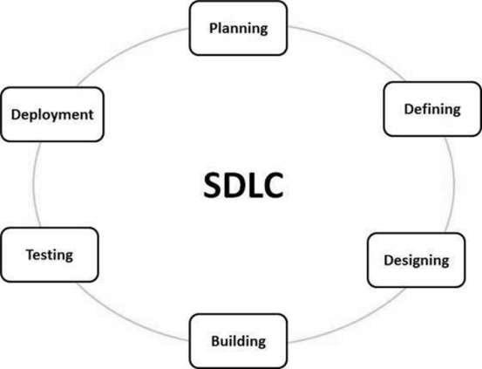

In other terms Software Development Methodology is a method that you can use as a guide procedure to make your proposed system work smoothly to avoid an error that might lead to a false or impulsive proposed project. That used framework structure, plan, and control the process of developing an information system or software. Every methodology software has their own step procedure that shows different strengths and weaknesses and helps you to find a software methodology that suits your current proposed project.

The researcher used Featured Driven Development Methodology that recognizes a systematic way of developing your current proposed system by following the five activities which helps to track progress and results of the project. FDD is useful because it demonstrates that you can focus on domain modeling on an iterative and incremental project.

Featured Driven Development is one of the favorite methods among development teams because it helps reduce confusion and rework of a proposed system. FDD was developed and refined by Jeff De Luca, Peter Coad and others. Featured Driven Development Methodology can be a good option for software development teams that are looking for structured, focused agile methodology that can deliver a good outcome to clients.

The Feature Driven Development (FDD) methodology processes involves: (1) that researcher can spend a short period of time since the beginning of the project in sequence to establish a clear understanding the study of your research while it is still on process (2) by the use of interpretation you can generate a plan without getting stuck in the analysis and design (3) to give the researcher allotted time to complete the process of building the project features individually , it also allows the teams to have an opportunity to work on each individual task to make sure that every functionalities are done according to the expected schedule. In other words, FDD methodology consists of five procedures to determine the elements of a project as a feature that involves designing and building these features in an iterative and incremental behavior. The figure below shows the illustration of the FDD process.

FIGURE 2 FEATURED DRIVEN DEVELOPMENT METHODOLOGY PROCESS

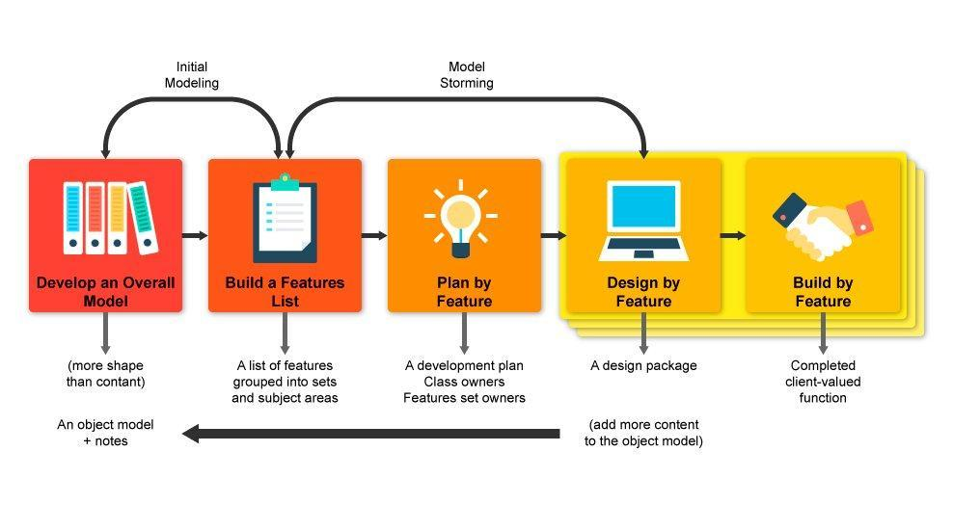

Develop an Overall Model- The researcher should focus on the overall scope of a proposed system rather than an individual content because the main goal of this is to give the whole objective of your study to fully understand the flow of your proposed system.

In this phase, researcher teams start collaborating ideas on how the system works from the beginning of the process by visualization and building the proposed system layout because the main concern of this phase was the layout rather than the content. The researcher starts creating the architecture and organization of those prototype parts of the system. In this way, the researcher was able to establish the extent of the system study.

Build a Features List - The researcher or the whole team itself uses these steps to identify every feature that might include developing the project feature activities.

In this phase, the researcher starts including all the necessary features that base on the study to be able complete the task and feature activities of the proposed system. Like those major features of the website that also contain sub features and eliminating those features that are not applicable for the project. In this way, the feature list became more organized.

Plan by Feature – After completing all the feature list, the researcher should set up the next step to produce the development plan and assign feature sets that belong to each developer programmers.

In this part the team starts working on building each feature according to their assigned task. The researcher discusses how the feature works, and why it is included on the system.

Design by Feature - The whole team should collaborate properly, and start working for the part of system design, while others work on the framework. By the end of the design stage, a design review is completed by the whole team before moving forward to the design of the project.

The researcher worried about the layout and the functionality of the feature groups. The researcher makes sure that each feature design is completed with each other, to avoid disordered layout of the proposed system. In this procedure some design was changed for being not appropriate, and also the functions of each feature will be explained.

Build by Feature - Team members should work on their individual build responsibilities at the same time visual designers on the UI, programmers on coded components, until it is finished. This is the important phase in FDD methodology and it is allotted the longest amount of time to properly complete the proposed system.

In this phase, the researcher coded the proposed system and features were created. Coding of the feature functionalities were presented, accomplishing the work on the proposed system with all the features with their design and functionalities. After coding, the proposed system was being tested to check if every feature and part worked according to what it was designed for.

# **Scope and Delimitation**

The project would focus on the PHINMA University of Pangasinan CITE Department only. In this study we conclude the following features of the website like Home, News/Update, Event, About, CITE Teacher Organizational Chart and Exams, the researcher goal was to give a reliable and legit information announcement towards the CITE Student.

The study shall not include the other department of PHINMA University of Pangasinan which is not included like CEA, CHS, CSS, AND CMA because it only focused on one department.

# **Data Gathering Techniques**

The researcher used a technique that are necessary to complete the development of PHINMA UPANG COLLEGE OF INFORMATION TECHNOLOGY EDUCATION BULLETIN WEBSITE which includes observation, survey with the possible users, documentation, and conducting a related topic that helps the process and made a summary. The process of gathering the data was done according to the interaction and collaboration of each individual idea of the member to accomplish the certain or given task that should be done on the set schedule.

Research – It allows the researcher to find information regarding how we should start making the project and ideas related to it.

Survey – The researcher conducts a survey that becomes another way of finding information that might be added to the website, especially the user’s feedback.

Documentation – In this part of the research, the teams start working on the document base from the study and everyone’s opinion that gathered as one supporting document of the study.

# **Sources of Data**

The researcher observes the process of PHINMA UPANG COLLEGE OF INFORMATION TECHNOLOGY EDUCATION BULLETIN WEBSITE that help the group to identify the problem of the current proposed system.

In this part of the study of proposed system we conduct a survey as one of the primary source of our data although it is through a virtual due to the reason that we cannot conduct the normal way of conducting a survey because were in the midst of pandemic to assure the safety and the possible participant and with the same reason we didn’t conduct an interview. We also base the data from the official Facebook page of College of Information Technology Department of University of Pangasinan. Through the official site we are able to know the necessary information that is important to include on our project. We are also able to determine the problem of why people or students do not inform on time regarding an announcement through a normal bulletin board because of the hassle of finding where the bulletin board is and the paper announcement posted might be displaced or unorganized. And we also do research that is related to the proposed system as a secondary part of the data to give support on our study to fully understand the main content of our proposed system.

Chapter 3

**DISCUSSION OF FINDINGS**

This chapter tackled the dilemmas and interpretation of the findings resulting from this study. The designs and features of the proposed project will be discussed.

Conceptual Design

The overall Purpose of this Website is to

show the main Features which is the announcement to give information and updates to the Students about the CITE Department and there are guides and frequently asked questions will be shown for the Students especially for freshmen. And Contact us if there are more questions they can send their concern about. This part is to give a better technique to quickly understand and to be a guide for the future.

**Features of the proposed system**

The information gathered by the researchers assists for the development of the proposed system including its advantages to the user. The respondents' suggestions are considered and applied.

Home page. In this feature once you open the website the first web page you will see is the home page where you can see the logo of PHINMA University of Pangasinan and the logo of COLLEGE OF INFORMATION TECHNOLOGY EDUCATION. In the upper portion of the home page you can click the About, Announcements, CITE Dept. Faculty, FAQ, Contact and Get started. If you click one of them you will be directed to their own web page, refer to figure 1.

Figure 1.

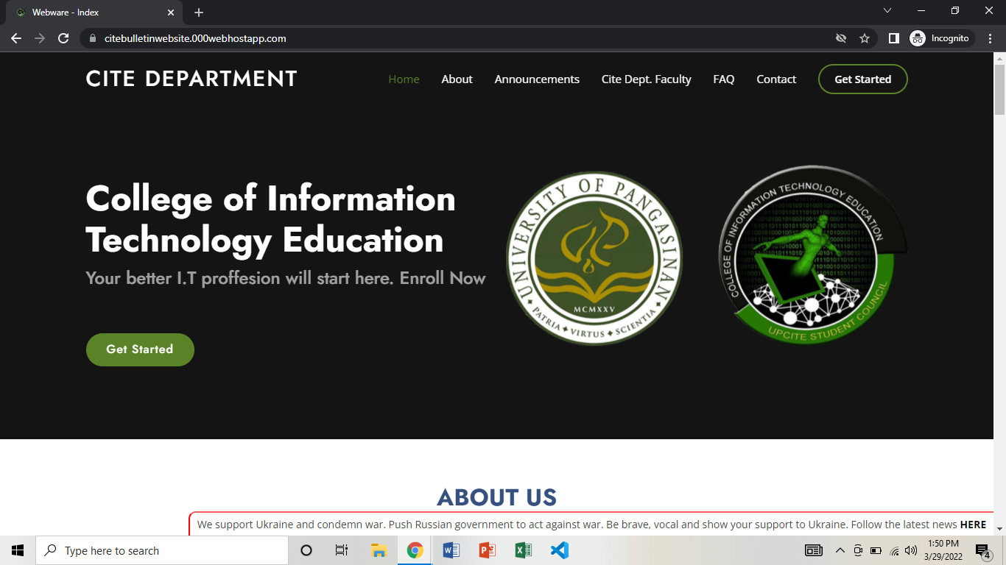

Figure 2.

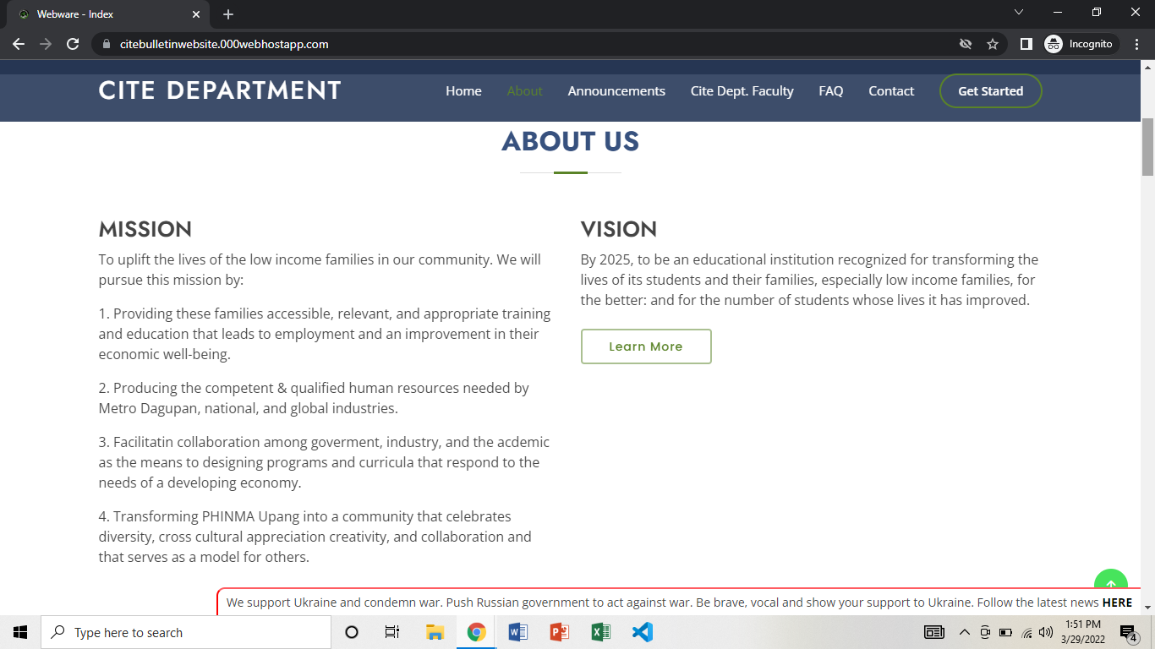

Shows the “About Us” where you can see and read the mission and vision of PHINMA University of Pangasinan.

Figure 3.

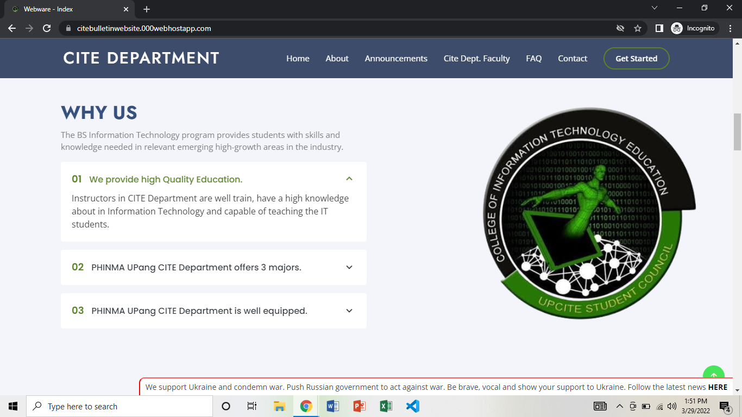

This feature is added so that students know that CITE Department faculties are well trained. PHINMA UPang CITE Department offers 3 majors, Programming, Web Development and Animation. The CITE Department is equipped with equipment that is used in building applications, websites and animation films.

Figure 4.

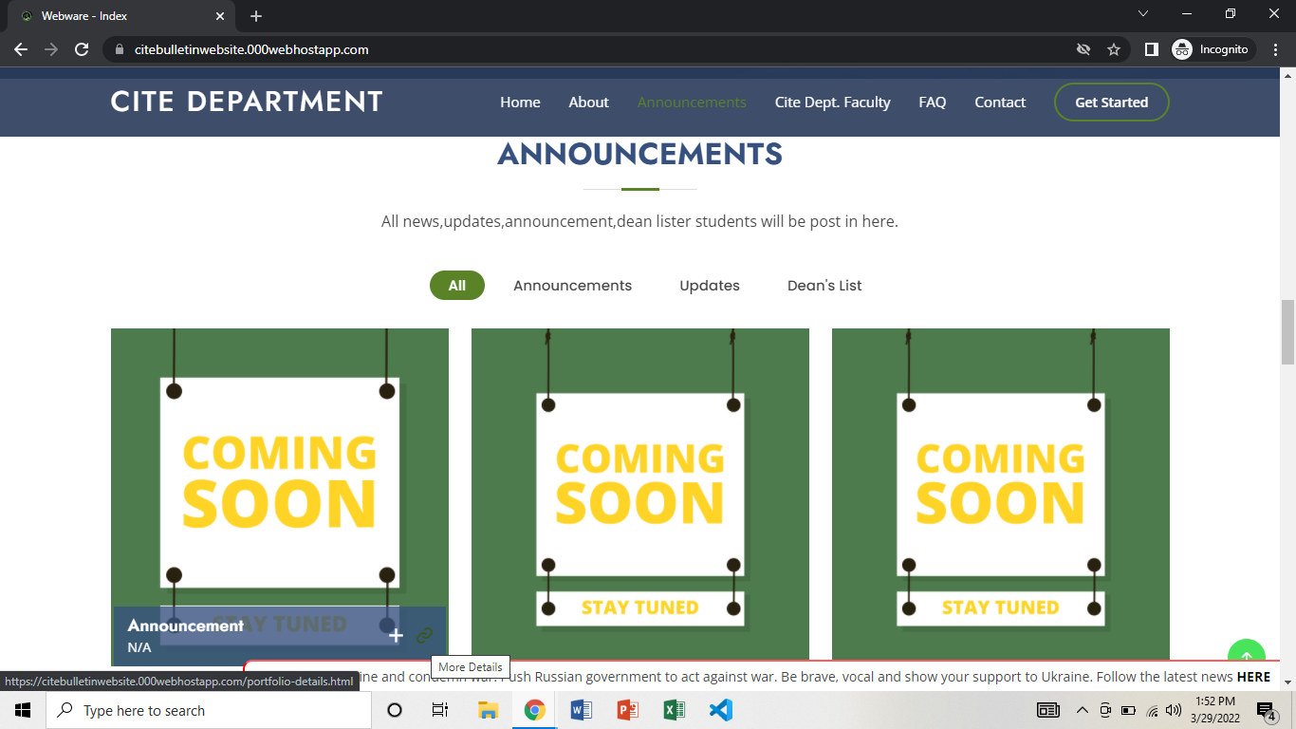

Announcement. This part, incoming events or news or updates from the CITE Department of PHINMA UPang are posted. So that students will inform and get legitimate information. Dean list students will also be posted so students know who is doing well in class.

Figure 5.

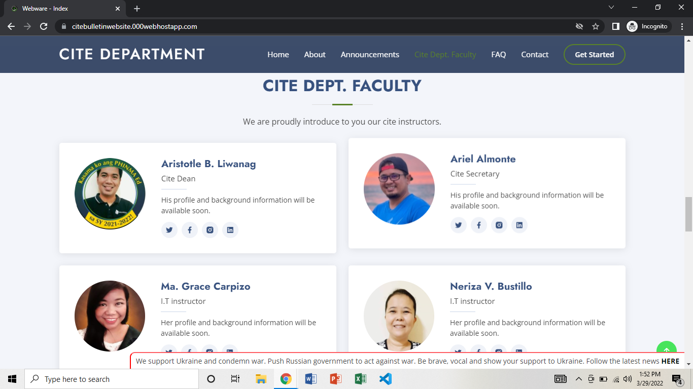

Cite dept faculty.This feature will help students to identify who are the faculties of PHINMA UPang CITE Department.

Figure 6.

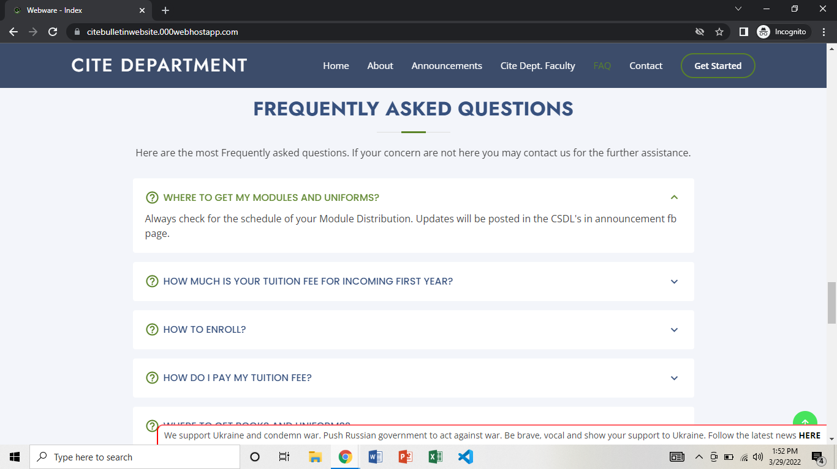

Frequently Asked Questions contain questions that are being asked frequently by the students. Once you click one of the questions it has already been answered and some of it has a link that once they click they will be directed on it.

Figure 7.

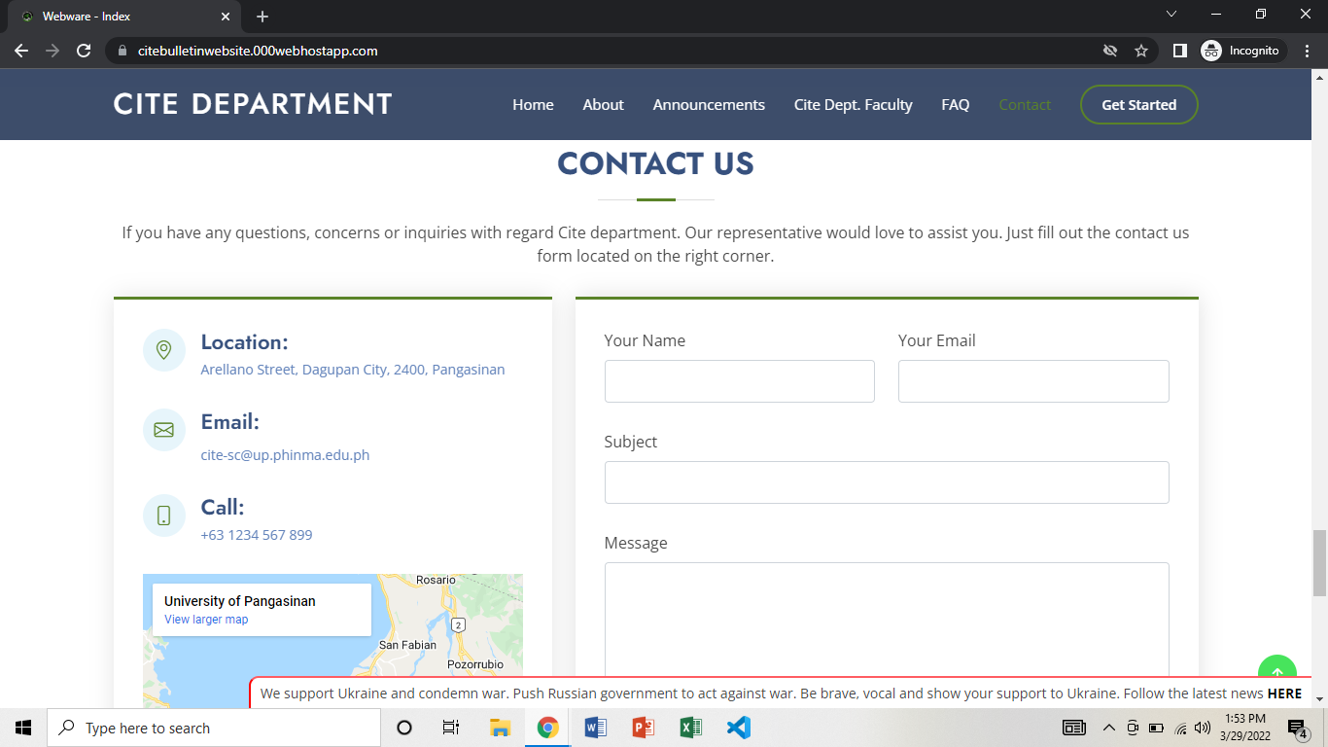

Contact Us.In this feature, if a student has a concern they can send an email to the website by filling up the form and it will be answered after being reviewed.

Figure 8.

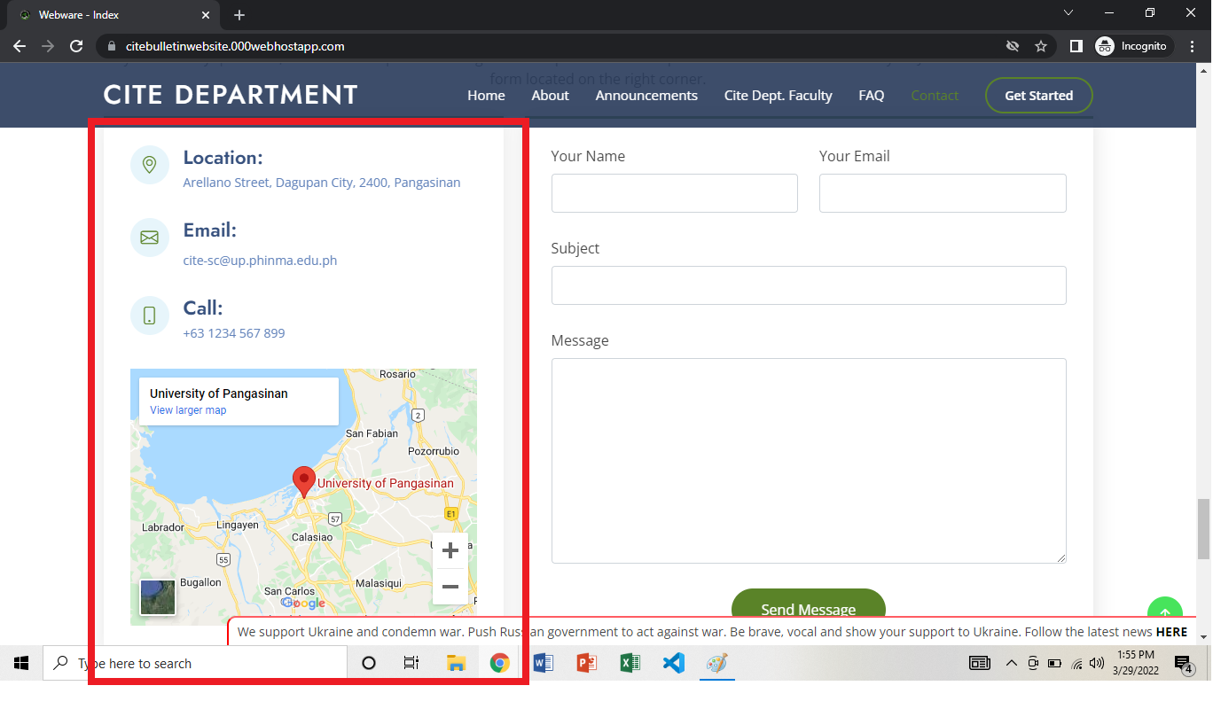

This feature shows the location of PHINMA UPang so that if a student wants to go and explore the campus they will not go lost.

Mobile View Figures.

Figure 9.1 Mobile View Home Page



Figure 10. Hamburger Button

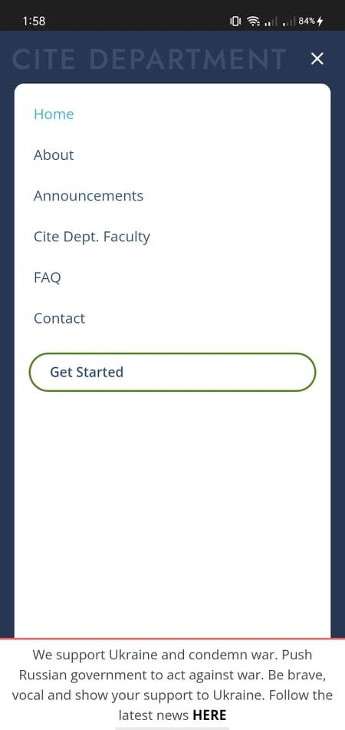

Figure 11. Mobile View About Us

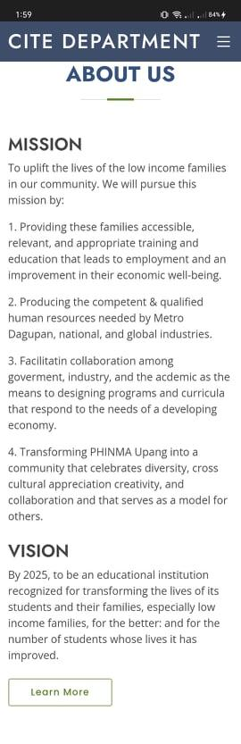

Figure 12. Mobile View Why Us

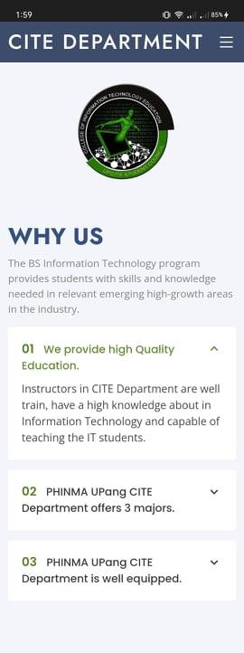

Figure 13. Mobile View Announcement



Figure 14. Mobile View CITE DEPT. Faculty

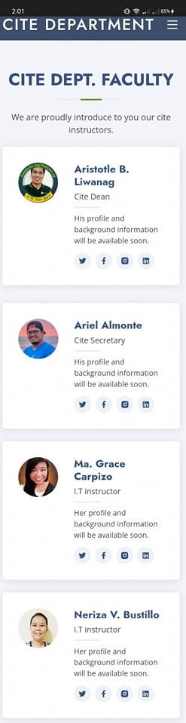

Figure 15. Mobile View FAQ

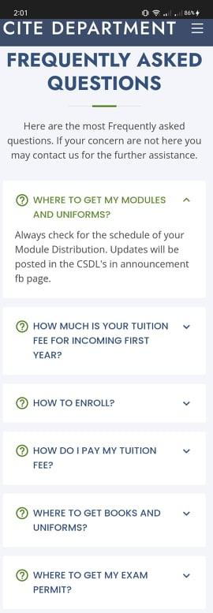

Figure 16. Mobile View Contact Us

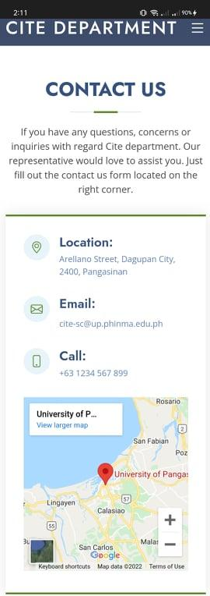

Figure 17. Mobile View Send message

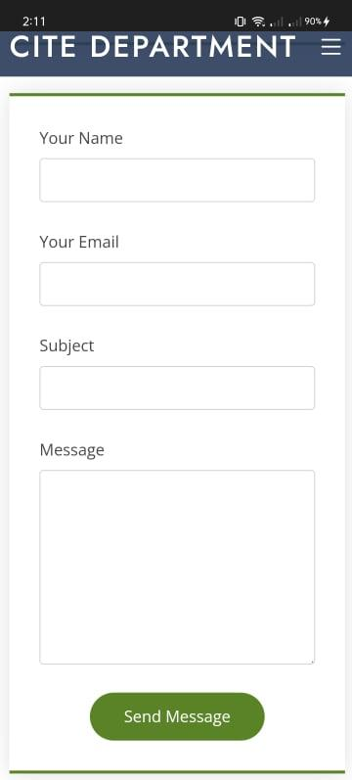

Figure 18. Mobile View Footer

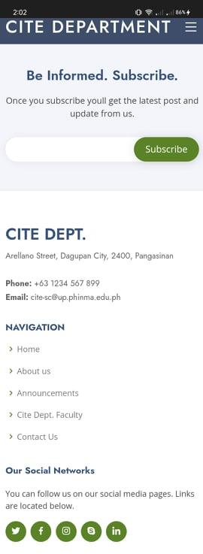

**Findings**

**Discussion of Findings**

Table 19. The result of the Gender survey in Phinma University of Pangasinan in the CITE department, most of them answered that Male were 69% and the females were only 27% and who chose better not to say was 4% out of 100% respondents.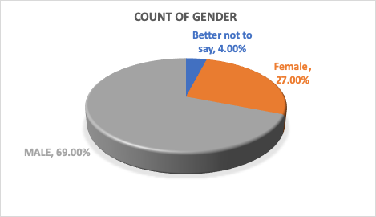

Figure 20. Based on the Result of Year Level in Phinma University of Pangasinan in CITE department, Our group was deploy the Survey in Students of CITE department which is the Second year, Third Year and Fourth Year, and the result was most of the answer is Second Year witch is 71% who participated and for the Third Year was 27% and lastly Fourth year 2% only who participated in total of 100% respondents.

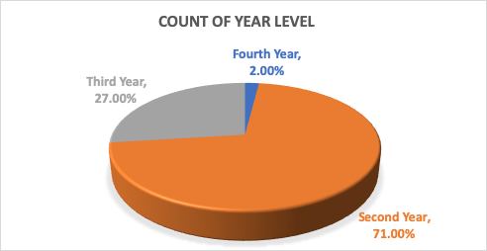

Figure 21. Based on the result of the survey the students of the CITE department most of the information they get is from University facebook page have 58% and when it comes to CITE Teacher it is only 19% and to the fellow IT students it has 20% in total of 10

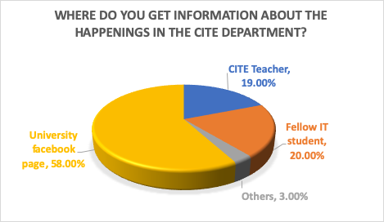

Figure 22. Based on the result of the survey about their thoughts about the online bulletin website for the CITE department most of them are Neutral have 43% and for the Very Useful are 12% for the Useful have 43% and who vote for Useless have 3% in total of 100%.

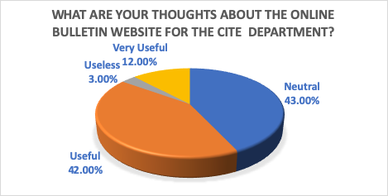

Figure 23. Base on the Result of the survey about the Bulletin website will be faster to update a Student

91% of the Students said YES, and 9% of the Students who voted NO in total of 100%.

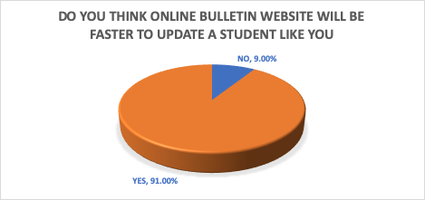

Figure 24. Base on the result of Survey about Online Bulletin Website will be helpful to the Students

93% of students vote for YES, and 7% of Students vote for NO in total of 100%.

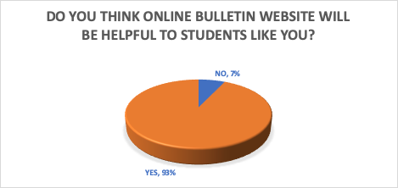

Figure 25. Based on the result of a survey about who encountered an online bulletin website most of the Students who vote for NO are 91% and for the Students who vote for YES are 9% in total of 100%.

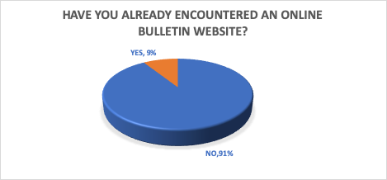

Figure 26. Based on the result of the survey about Agree on Creating bulletin website for the CITE department, most of the Students who voted for Yes were 90% and Students who voted for no was 10% in total of 100%.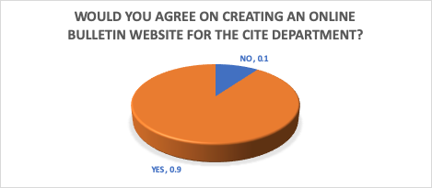

Figure 27. Website Features

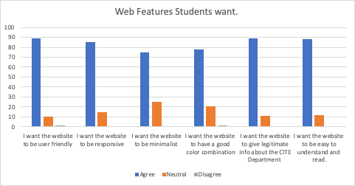

Base on the result of I want the website to be user friendly have

89 of the Students who vote agree and 10 Students who vote for Neutral and 1 Student who vote for Disagree.

And Base on the result of I want the website to be responsive have

85 of the Students who vote agree and 15 Students for Neutral and no one who votes for Disagree.

And Base on the result of I want the website to be minimalist have

75 of the Students who vote agree and 25 Students and no one who votes for Disagree.

And Base on the result of I want the website to have a good color combination have

78 of the Students who vote for agree and 21 Students who vote for Neutral and 1 Student who vote for Disagree

And based on the result I want the website to give legitimate info about the CITE Department having 89 of the Students who vote for agree and 11 Students for Neutral and no one who vote for Disagree.

And Base on the result of I want the website to be easy to understand and read have

88 of the Students who vote agree and 12 Students for Neutral and no one who votes for Disagree.

Logical Design

A logical design is a set of blueprints, it describes the actual processes of entering, verifying and storing data.

Use Case Diagram. A use case diagram shows various use case and different types of users the system has and will often be accompanied by other types of diagram as well. It is a graphical depiction of a user’s possible interaction with a system.

This Figure shows the use-case diagram for the proposed Human Resource Information Management for PHINMA University of Pangasinan.

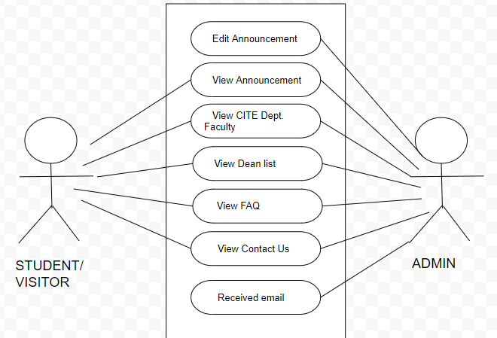

Hardware Requirements. Hardware requirements are a set of physical components essentially to run the system processes.

**Hardware requirements**

| **HARDWARE** | **MINIMUM SPECIFICATION** |
| --- | --- |
| Processor | Intel Pentium 4 |
| Memory | 2GB RAM |
| Operating System | Android |
| Smart Phone Memory | 2GB RAM |

Software Requirements. The proposed PHINMA UPang College of Information Technology Bulletin Website was designed using a sublime, cascading style sheet as a front end that will enable the system to associate with the different functions and controls.

**Software Requirement**

| **SOFTWARE** | **SPECIFICATION** |
| --- | --- |
| Authoring Language | Hypertext Markup Language |
| Operating System | At least Windows XP |
| Editor | Sublime |
| Web Browser | Google Chrome,Internet Explorer |
| Web Design | Cascading Style Sheet(CSS) |
|  |  |

Chapter 4

**CONCLUSIONS AND RECOMMENDATIONS**

This chapter presents the conclusions and recommendations of the study.

**Conclusions**

The purpose of this research is to give better and legitimate information to the students so that they can avoid fake news.

Students in the CITE Department will easily understand what is happening in the department. It will be very helpful because they can see the announcements online thru laptop or pc, they can open with their smartphone and they can browse even at home. They can send emails of their concerns to Contact us. And they can easily recognize the faculties of PHINMA UPang CITE Department.

**Recommendations**

Based on the findings and conclusions of the study, the researchers recommend the following:

1. CITE Students should based on legit information.
2. CITE Students should use the proposed system so they can get legitimate information and avoid false information.

**REFERENCES**

A. Published Materials

Best, John (1970), Research in education, second edition New Hensley: Prentice Hall, Inc.

B. Websites

SAP WordPress.COM (2012), Why do companies use SAP? article, SAP forums for solutions, Retrieved November 30, 2012

**APPENDICES**

Appendix A

INFORMED CONSENT LETTER

College of Information Technology Education

PHINMA-UPANG

Dagupan City, Philippines 2400

Informed Consent:

Thank you for participating in this survey. Your feedback is important. Please answer the following questions as honestly as possible. These questions concern the PHINMA UPANG COLLEGE OF INFORMATION TECHNOLOGY EDUCATION BULLETIN WEBCITE.

The purpose of this survey is to help the researchers to know who are interested in creating an online bulletin website for the CITE Department. We do not anticipate that taking this survey will contain any risk or inconvenience to you. Furthermore, your participation is strictly voluntary and you may withdraw your participation at any time without penalty.

All information collected will be used only for our research and will be kept confidential. There will be no connection to you specifically in the results or in future publication of the results. Once the study is completed, we would be happy to share the results with you if you desire. In the meantime, if you have any questions and/or concerns about your treatment as a participant in this study, please ask or contact:

Edrin James Edades - edde.edades.up@phinmaed.com

Melanie Ferrer - elva.ferrer.up@phinmaed.com

Joshua Velasquez- joco.velasquez.up@phinmaed.com

Although the chairperson may ask your name, all complaints are kept in confidence. By answering our survey, you are verifying that you have read the explanation of the study, and that you agree to participate. You also understand that your participation in this study is strictly voluntary.

Appendix B

Pre-test Questionnaire

Instructions: Please put a check mark (√) beside your chosen answer(s). For open-ended questions, please try to write clearly.

Part I. Knowing your Details

1. Name (optional):_____________________________
2. Gender:

[ ] MALE

[ ] FEMALE

[ ] Better not to say

1. Year level:

[ ] Second Year

[ ] Third Year

[ ] Fourth Year

Part II. About the PHINMA UPANG CITE Bulletin website

1. Where do you get information about the happenings in the CITE Department?

[ ] University facebook page

[ ] CITE Teacher

[ ] Fellow IT student

[ ] Others

2. What are your thoughts about the online bulletin website for the CITE Department?

[ ] Useless

[ ] Neutral

[ ] Useful

[ ] Very Useful

3. Do you think online bulletin website will be faster to update a student like you?

[ ] YES

[ ] NO

4. Do you think online bulletin website will be helpful to students like you?

[ ] YES

[ ] NO

5. Have you already encountered an online bulletin website?

[ ] YES

[ ] NO

6. Would you agree on creating an online bulletin website for the CITE Department?

[ ] YES

[ ] NO

If you answered YES in preferring a system, please answer the following statements below. Check one box for each statement.

| Statements | Agree | Neutral | Disagree |
| --- | --- | --- | --- |
| I want the website to be user friendly. |  |  |  |
| I want the website to be responsive |  |  |  |
| I want the website to be minimalist |  |  |  |
| I want the website to be easy to understand and read. |  |  |  |
| I want the website to have a good color combination. |  |  |  |
| I want the website to give legitimate info about the CITE Department. |  |  |  |
|  |  |  |  |

**CURRICULUM VITAE**

**EDRIN JAMES D. EDADES**

Brgy. Bued Calasiao Pangasinan

09270165647

edrinjamesedades@gmail.com

**___________________________________________________________**

**PERSONAL INFORMATION**

Birthdate: January 14, 2000

Civil Status: Single

Gender: Male

Religious Affiliation: Christian Born Again

**___________________________________________________________**

**EDUCATIONAL ATTAINMENT**

Tertiary: Bachelor of Science in Information Technology, 2018 to present

PHINMA University of Pangasinan

Secondary: Calasiao Comprehensive National High School, 2018

Elementary: Bued East Elementary School, 2012

**___________________________________________________________**

**WORK HISTORY**

Freelance Work

**___________________________________________________________**

**IT SKILLS AND CERTIFICATIONS**

1. Knowledge on Editing photos.
2. Knowledge on Editing videos.
3. Knowledge on Frontend

**___________________________________________________________**

**RESEARCH PRESENTATIONS AND PUBLICATIONS**

**CURRICULUM VITAE**

**Allan Paul I. Bacani**

Brgy. Ican Malasiqui, Pangasinan

09777696310

[Allanpaulbacani21@gmail.com](mailto:Allanpaulbacani21@gmail.com)

**___________________________________________________________**

**PERSONAL INFORMATION**

Birthdate: January 25, 2001

Civil Status: Single

Gender: Male

Religious Affiliation: Catholic

**___________________________________________________________**

**EDUCATIONAL ATTAINMENT**

Tertiary: Bachelor of Science in Information Technology, 2019 to present

PHINMA University of Pangasinan

Secondary: Malasiqui Agno Valley College, 2019

Elementary: Ican Elementary School, 2013

**___________________________________________________________**

**WORK HISTORY**

N/A

**___________________________________________________________**

**I.T SKILLS AND CERTIFICATIONS**

1. Proficient in Microsoft Office

2. Basic knowledge on frontend development

3. Experienced in Photoshop and video editing app.

4. Can be able to type 60 word per minute

**___________________________________________________________**

**RESEARCH PRESENTATIONS AND PUBLICATIONS**

**CURRICULUM VITAE**

**Carl Jamel J. Castañares**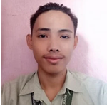

504 America St. Bonuan Binloc,

Dagupan City, Pangasinan

09100294030

Cajo.castanares.up@phinmaed.com

**___________________________________________________________**

**PERSONAL INFORMATION**

Birthdate: November 15, 1999

Civil Status: Single

Gender: Male

Religious Affiliation: Roman Catholic

**___________________________________________________________**

**EDUCATIONAL ATTAINMENT**

Tertiary: Bachelor of Science in Information Technology, 2018 to present

PHINMA University of Pangasinan

Secondary: Mangaldan National High School, 2018

Elementary:Clarice Angels School, 2012

**___________________________________________________________**

**WORK HISTORY**

Freelancing

**___________________________________________________________**

**IT SKILLS AND CERTIFICATIONS**

1. Knowledge on HTML

2. Knowledge on CSS

3. Knowledge on Bootstrap

4. Knowledge on Editing

**___________________________________________________________**

**RESEARCH PRESENTATIONS AND PUBLICATIONS**

**CURRICULUM VITAE**



**Melanie V. Ferrer**

237 Lasip Calasiao, Pangasinan

09518777420

melaniefe567@gmail.com

**___________________________________________________________**

**PERSONAL INFORMATION**

Birthdate: August 2, 2000

Civil Status: Single

Gender: Female

Religious Affiliation: Roman Catholic

**___________________________________________________________**

**EDUCATIONAL ATTAINMENT**

Tertiary: Bachelor of Science in Information Technology, 2019 to present

PHINMA University of Pangasinan

Secondary: Calasiao Comprehensive National High School, 2019

Elementary: Balingit Constantino Lasip Elementary School, 2013

**___________________________________________________________**

**WORK HISTORY**

N/A

**___________________________________________________________**

**IT SKILLS AND CERTIFICATIONS**

1. Knowledge in Research

2. Knowledge on html

3. Experience in Adobe Photoshop

**___________________________________________________________**

**RESEARCH PRESENTATIONS AND PUBLICATIONS**

**CURRICULUM** **VITAE**



**EDWIN S. MALLARE JR.**

Brgy. Osmeña Mangatarem Pangasinan

09065563846

edwinmallare042@gmail.com

**___________________________________________________________**

**PERSONAL INFORMATION**

Birthdate: August 30, 2000

Civil Status: Single

Gender: Male

Religious Affiliation: Catholic

**___________________________________________________________**

**EDUCATIONAL ATTAINMENT**

Tertiary: Bachelor of Science in Information Technology, 2019 to present

PHINMA University of Pangasinan

Secondary: Mangatarem National High School, 2019

Elementary: Mangatarem 2 Central School, 2013

**___________________________________________________________**

**WORK HISTORY**

N/A

**___________________________________________________________**

**IT SKILLS AND CERTIFICATIONS**

1. Knowledge on Frontend

2. Knowledge on Editing Web

3. Knowledge on Editing Multimedia adobe.

**___________________________________________________________**

**RESEARCH PRESENTATIONS AND PUBLICATIONS**